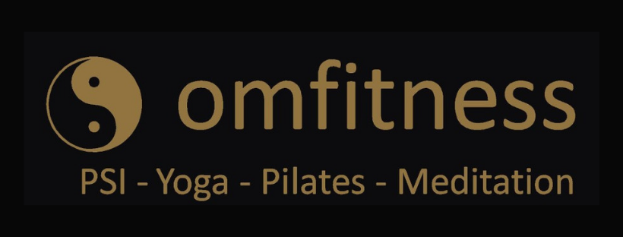
Notton Village Hall - Tuesdays

iMovefreely Pilates 12:00 – 1:00
£6 per session
This is a system of injury prevention & movement preparation techniques, preceded by Pilates exercises, floor and standing work. Mats provided

Postural stability Instruction 1:30 – 2:30
£6 per session
A Functional, challenging evidence based session with seated and standing work, centering on senior students meeting their appropriate exercise needs, including balance/falls prevention exercises.

A Health history consent form must be completed before starting class, so please come a bit early to complete a form if you are new to the class.
Contact: info@omfitness.uk
Phone: 07947563806
Web: www.omfitness.uk

